Aerial Insectivore results from BBS analysis, data-version 2018 (i.e., including 2018 BBS data).

In this [Google Drive “Aerial Insectivores BBS 2018”](https://drive.google.com/open?id=1WqWa-DQ2nsV8tiMzQi712Gd8nSBEZfxe), you will find a selection of new BBS results and State of Birds indicators for aerial insectivores (AI), at regional, national, and continental scales. The results are drawn from a new BBS model, which I described in a Landbird Technical Committee meeting on March 4th. This new model is particularly well designed to track non-linear patterns in populations, such as the early-1980’s change point for aerial insectivores.

There are two main folders.

1. Species_results_2018_BBS_Analysis. This folder contains a selection of species-level results for aerial insectivores from the 2018 analysis. It is only a selection of the types of results available.
   1. **To look at trend estimates for all species, time-periods, and regions:** “AI trends BBS 2018.csv”
   2. **To explore the geographic patterns in population change**:
      1. Geofacet Trajectories: These are faceted trajectory graphs with stratum-level population trajectories, in Province/State facets, arranged in an approximately geographic layout.  
         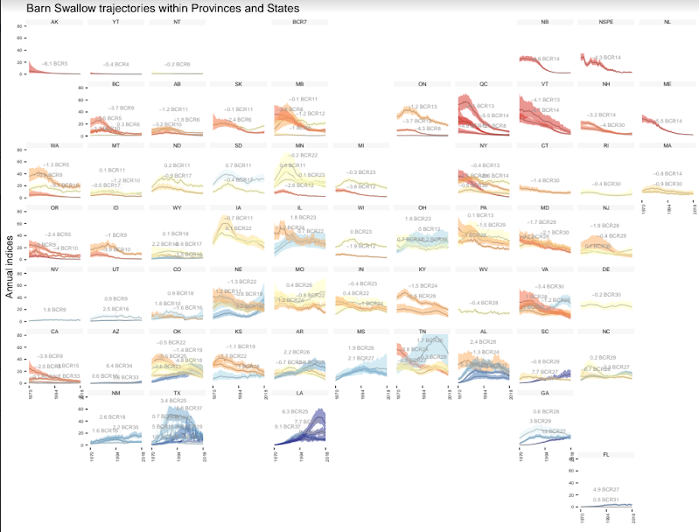
      2. Trend Maps: These are maps of the geographic strata coloured by the short and long term trend values.  
         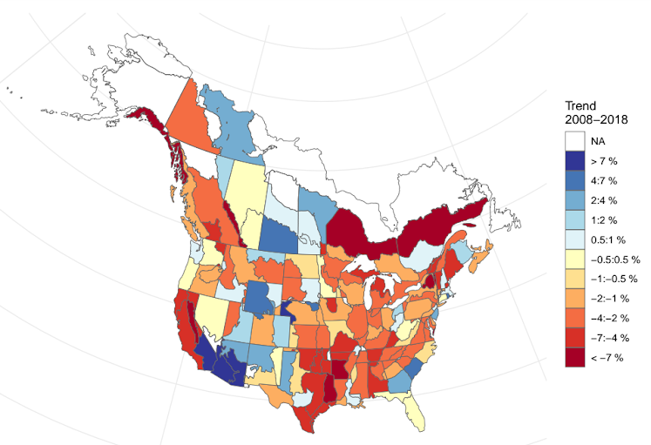
   3. **To examine the detailed population trajectories at all spatial scales for a given species**; Indices plots show the population trajectory (in light blue) the component of the trajectory used for trend estimation (in orange), and the trend value in orange text, as well as the number of routes (green bars along x-axis, and the observed mean counts, light blue dots).  
      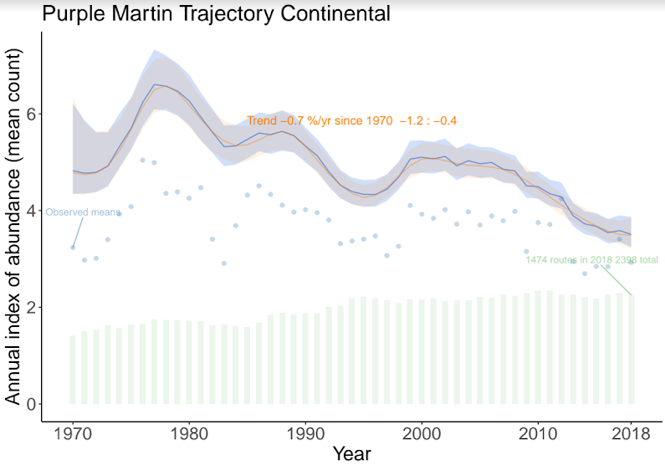
2. **Composite Trajectories (State of Birds Indicator lines**). This folder contains the State of Canada’s Birds (SOCB) analyses for AI, using these new BBS results. The SOCB model has been applied to three different groupings of aerial insectivores: Swallows Swifts and Nightjars, Flycatchers, and the SOCB-AI grouping which included all Swallow Swifts and Nightjars with some distribution in Canada plus three flycatchers (Eastern and Western Wood-Peewee, and Olive-sided Flycatcher). For each of these three groups, there’s a sub-folder that contains all of the results for the composite model applied at the following scales: Continental, national, and province/state. Note: all of these groupings exclude Cave Swallows, as their extreme increase greatly increases the uncertainty of the group patterns. IF you’re interested in the code, it’s available at this [GitHub repository](https://github.com/AdamCSmithCWS/Aerial_Insectivores).
   1. **To explore the species-level patterns within the indicators.** There are files with “spaghetti” in their name. For example, “Continental SOCB indexspaghetti w sp.pdf”. These are plots of the composite species indicators (i.e., the SOCB-indicator line) on top of each species’ line (hence the term spaghetti).  
      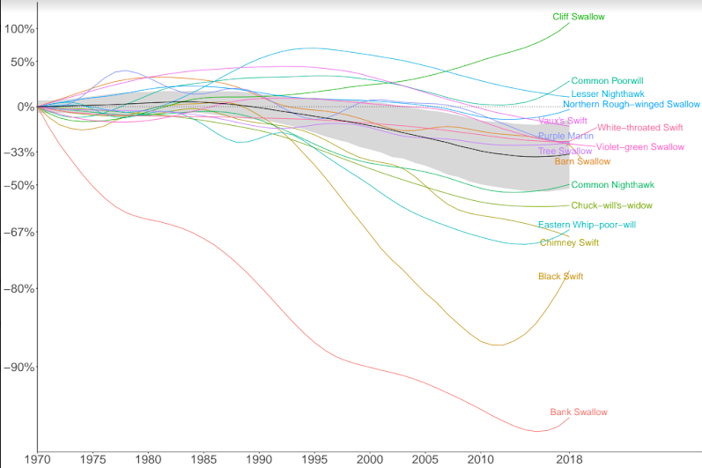
   2. **To explore the geographic variation in the indicators:** There are also three files with “geofacet” in their name. For example, “Swallows_Swifts_Nightjars indicator geofacet plot by prov_state.pdf”.   
      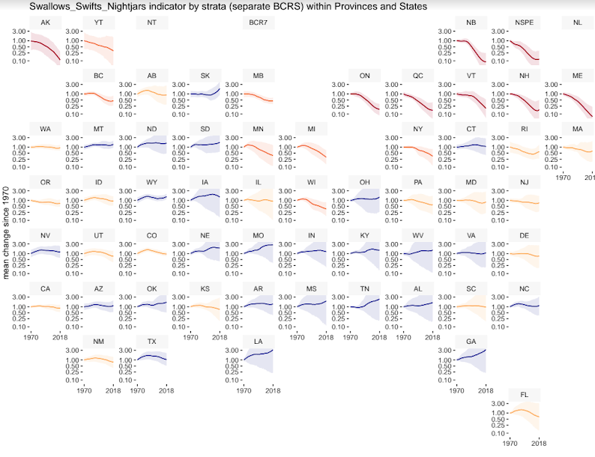  
      These plots are faceted graphs, grouped by State/Province, showing the composite indicator lines for the groups. There are two indicator plots (one showing just the Prov/State lines and another that shows the stratum-level breakdowns of the lines (e.g., the Ontario facet has lines for BCRs 13, 12, and maybe 8). The third file includes a page for each species, showing their individual lines, at the State/Prov level, as it contributes to the overall indicator.

**EXTRA BBS results: I** think I’ve put everything you’ll likely need in the Aerial Insectivore folder. But, if you’re looking for something else from the entire set of 2018 results (all species and all results). You can explore this **alternative** [Google drive “BBS Status and Trend CWS data version 2018](https://drive.google.com/open?id=1OTqdql4oGTGqwDNWcEIHtpamrSifvp-f)”. In that folder, you’ll also find a recording of the March 4th presentation and a draft manuscript describing the new BBS model.